ASSIGNMENT17-01-22:

## QUESTION 1: Write a program that can change the text of a button on its click

## CODE:

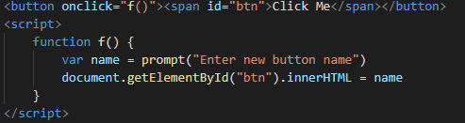

## OUTPUT:

# 1. First Click on [Click Me Button]

Screenshot 2022-01-19 002814.png

# 2. Then after clicking , Enter a new button name

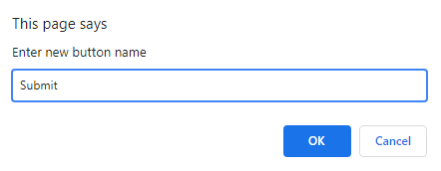

# 3. Button Name changed

Screenshot 2022-01-19 002918.png

## QUESTION 2: Write a program to take the data from 3 <li> tags and concatenate them, then show the results in alert

## CODE:

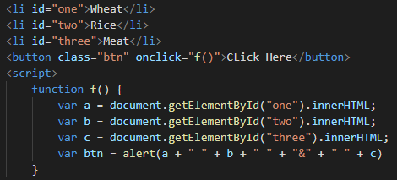

## OUTPUT:

## 1.

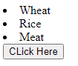

# 2. After Click Here the page shows:

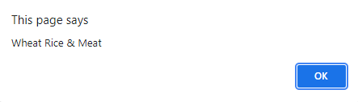

## QUESTION 3: Write a program that takes the data from the heading tag and put it in 5 <li> tags

## CODE:

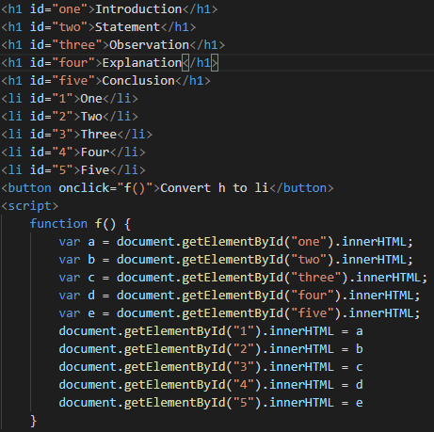

## OUTPUT:

# Before Conversion After Conversion

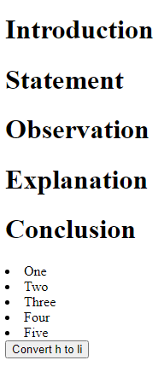 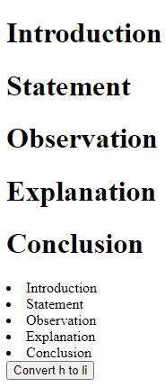

## QUESTION 4: Write a program that prints a table of a number in <p> tag using .innerhtml

## CODE:

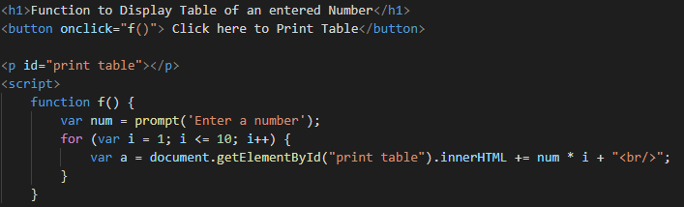

## OUTPUT:

# Click on the button[‘Click here to Print Table’]

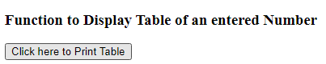

# Enter a number

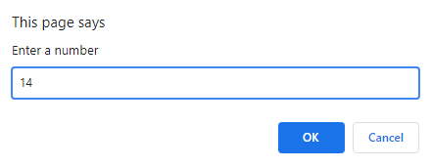

# I’ve entered number 14 therefore , it displayed the table of 14.

